**Exercise 4: Functions**

**Scenario 1:** Calculate the age of customers for eligibility checks.

* + **Question:** Write a function CalculateAge that takes a customer's date of birth as input and returns their age in years.

**QUERY:**

CREATE OR REPLACE FUNCTION Calculate_Age(

DOB IN DATE

)

RETURN NUMBER

IS

age NUMBER;

BEGIN

age := TRUNC(MONTHS_BETWEEN(SYSDATE, DOB) / 12);

RETURN age;

END Calculate_Age;

SELECT Calculate_Age(

(SELECT DOB FROM Customers WHERE CustomerID = 1)

) AS Age

FROM dual;

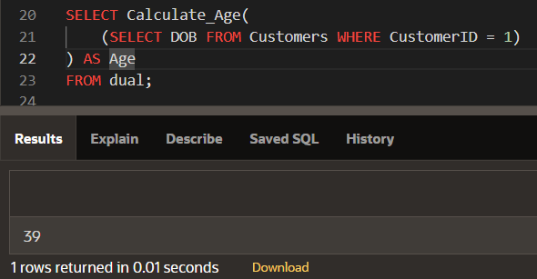

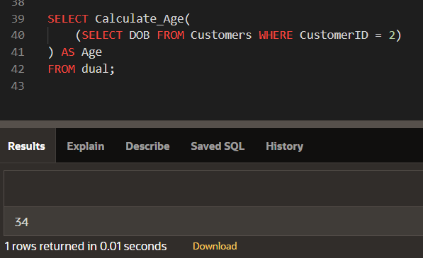

**Scenario 2:** The bank needs to compute the monthly installment for a loan.

* + **Question:** Write a function **CalculateMonthlyInstallment** that takes the loan amount, interest rate, and loan duration in years as input and returns the monthly installment amount.

**QUERY:**

CREATE OR REPLACE FUNCTION Calculate_EMI(

loan_amount IN NUMBER,

annual_interest_rate IN NUMBER,

total_months IN NUMBER

) RETURN NUMBER

IS

monthly_interest_rate NUMBER;

emi NUMBER;

BEGIN

monthly_interest_rate := annual_interest_rate / (12 * 100);

emi := (loan_amount * monthly_interest_rate * POWER((1 + monthly_interest_rate), total_months)) /

(POWER((1 + monthly_interest_rate), total_months) - 1);

RETURN emi;

END Calculate_EMI;

SELECT ROUND(

Calculate_EMI(

(SELECT LoanAmount FROM Loans WHERE LoanID = 1),

(SELECT InterestRate FROM Loans WHERE LoanID = 1),

(SELECT MONTHS_BETWEEN(EndDate, StartDate) FROM Loans WHERE LoanID = 1)

), 2

) AS Monthly_Installment

FROM dual;

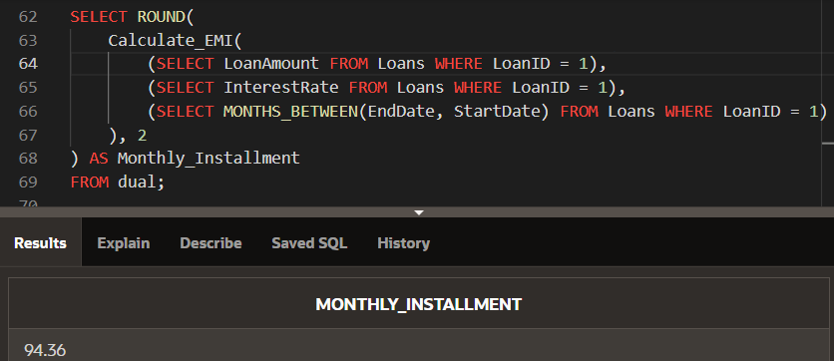

**Scenario 3:** Check if a customer has sufficient balance before making a transaction.

* + **Question:** Write a function **HasSufficientBalance** that takes an account ID and an amount as input and returns a boolean indicating whether the account has at least the specified amount.

**QUERY:**

CREATE OR REPLACE FUNCTION Check_Account_Balance(

p_AccountID IN NUMBER,

p_Amount IN NUMBER

) RETURN BOOLEAN

IS

v_Balance NUMBER;

BEGIN

SELECT Balance INTO v_Balance

FROM Accounts

WHERE AccountID = p_AccountID;

IF v_Balance >= p_Amount THEN

RETURN TRUE;

ELSE

RETURN FALSE;

END IF;

EXCEPTION

WHEN NO_DATA_FOUND THEN

RETURN FALSE;

END Check_Account_Balance;

DECLARE

v_Result BOOLEAN;

BEGIN

v_Result := Check_Account_Balance(1, 500);

DBMS_OUTPUT.PUT_LINE('Has sufficient balance: ' || CASE

WHEN v_Result THEN 'TRUE'

ELSE 'FALSE'

END);

END;

